**Project Title** **:** **PetCare+ – Specialized Veterinary Treatment Slot Booking System**

**PHASE 3**

**1.Standard & Custom Objects**

* What it does: Objects are like tables in a database—they store all the data for your application. Standard objects (like Contact or User) are provided by Salesforce. Custom objects store data specific to your project.
* What you need:
  + Pet__c (Custom Object) – Stores all pet details.
  + Slot__c (Custom Object) – Stores booking slots for treatments.
  + Treatment__c (Custom Object) – Stores doctor treatment notes and follow-ups.
  + Contact (Standard Object) – Stores pet owner information.
  + User (Standard Object) – Stores doctor and receptionist accounts.
* How it helps: Provides the core structure of your app. Enables tracking pets, their appointments, treatments, and owners in an organized way.

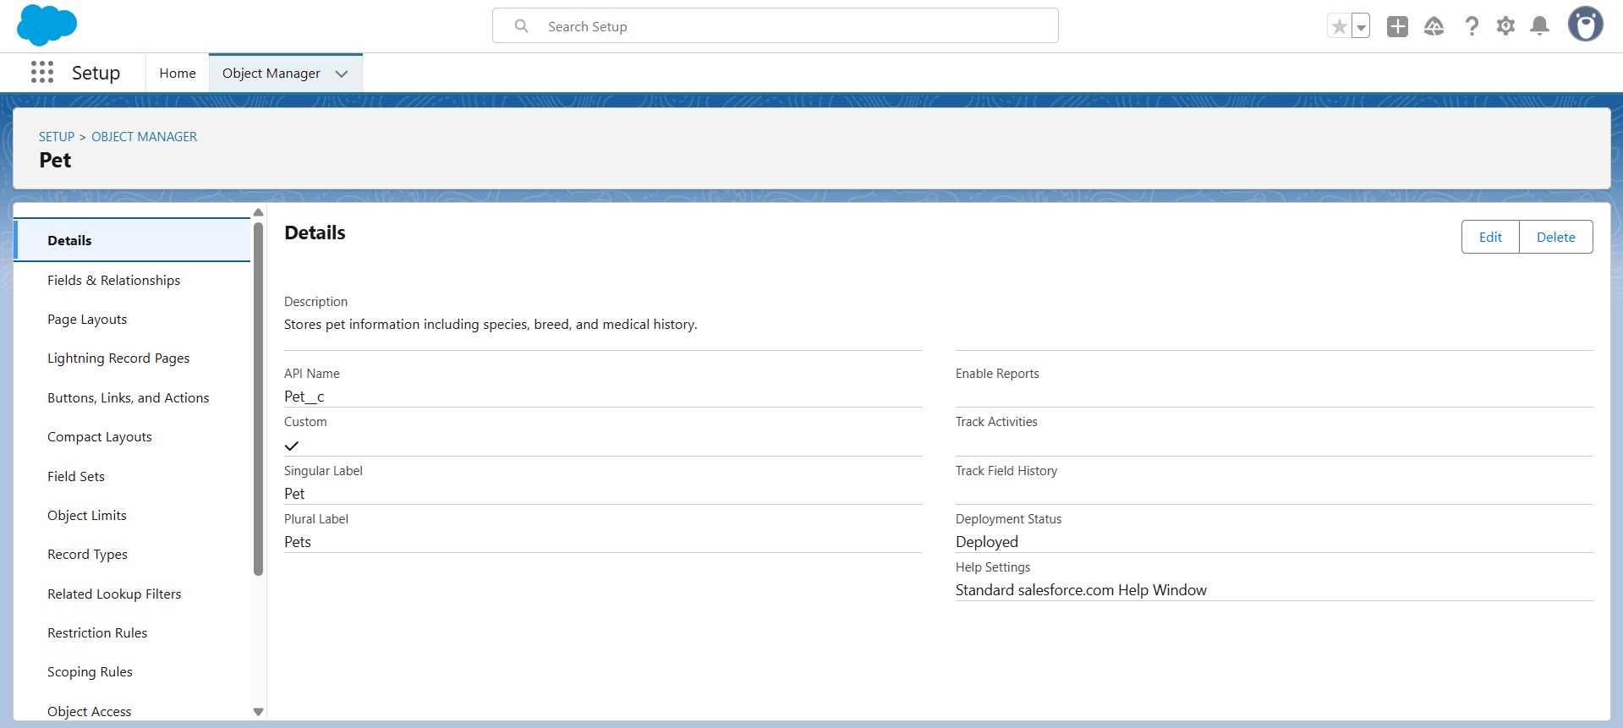

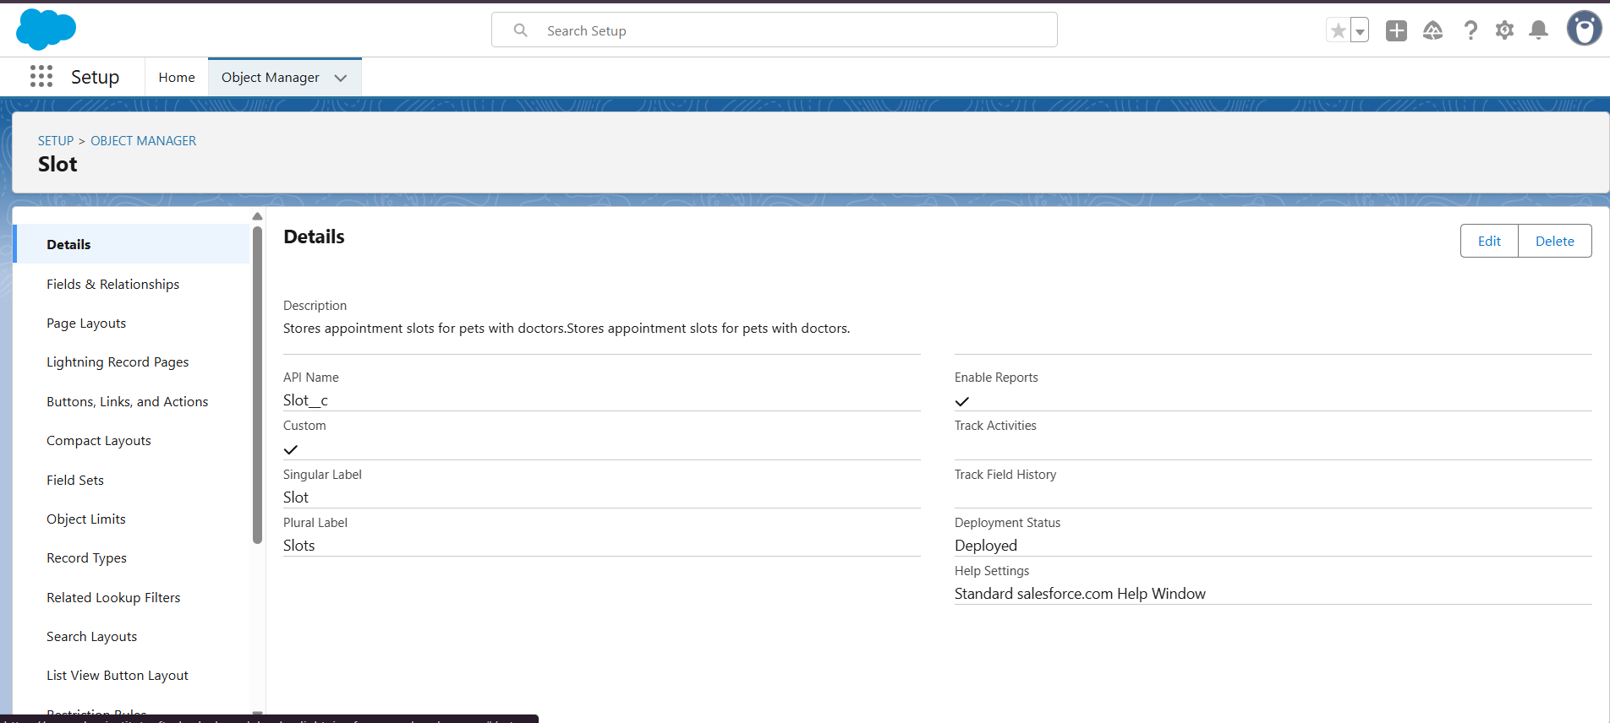

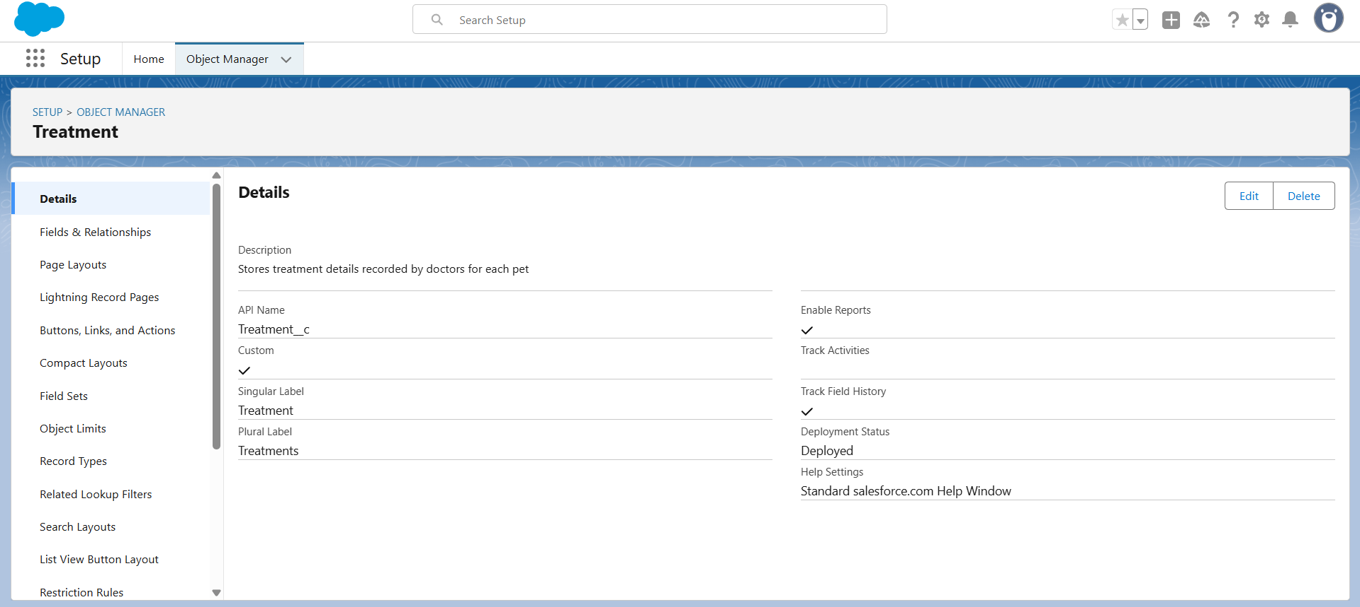

**2. Fields**

* What it does: Fields define what data each object can store (like columns in a table).
* What you need:
  + Pet__c: Name, Owner__c (Lookup to Contact), Species__c, Breed__c, Age__c, Gender__c, Medical_History__c,
  + Slot__c: Name, Pet__c (Master-Detail to Pet__c), Doctor__c (Lookup User), Date__c, Status__c, Notes__c, [Slot_ID](https://mangaloreinstituteoftechn-b-dev-ed.develop.lightning.force.com/lightning/setup/ObjectManager/01Ifj000002n3d7/FieldsAndRelationships/Name/view), Specialization__c,
  + Treatment__c: Name, Pet__c (Master-Detail to Pet__c), Doctor__c (Lookup User), Treatment_Details__c, Follow_Up_Date__c, Slot__c, Treatment_ID_c
* How it helps: Ensures all relevant information is captured, stored, and easily accessible for users based on their roles.

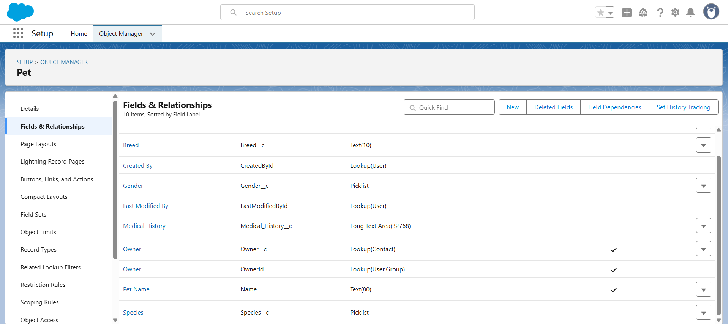

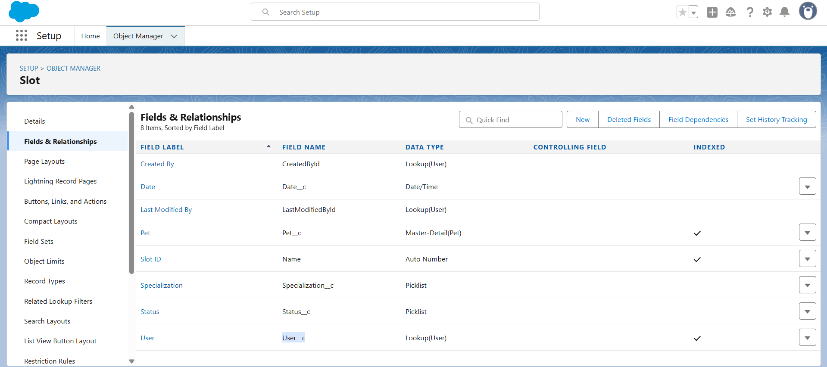

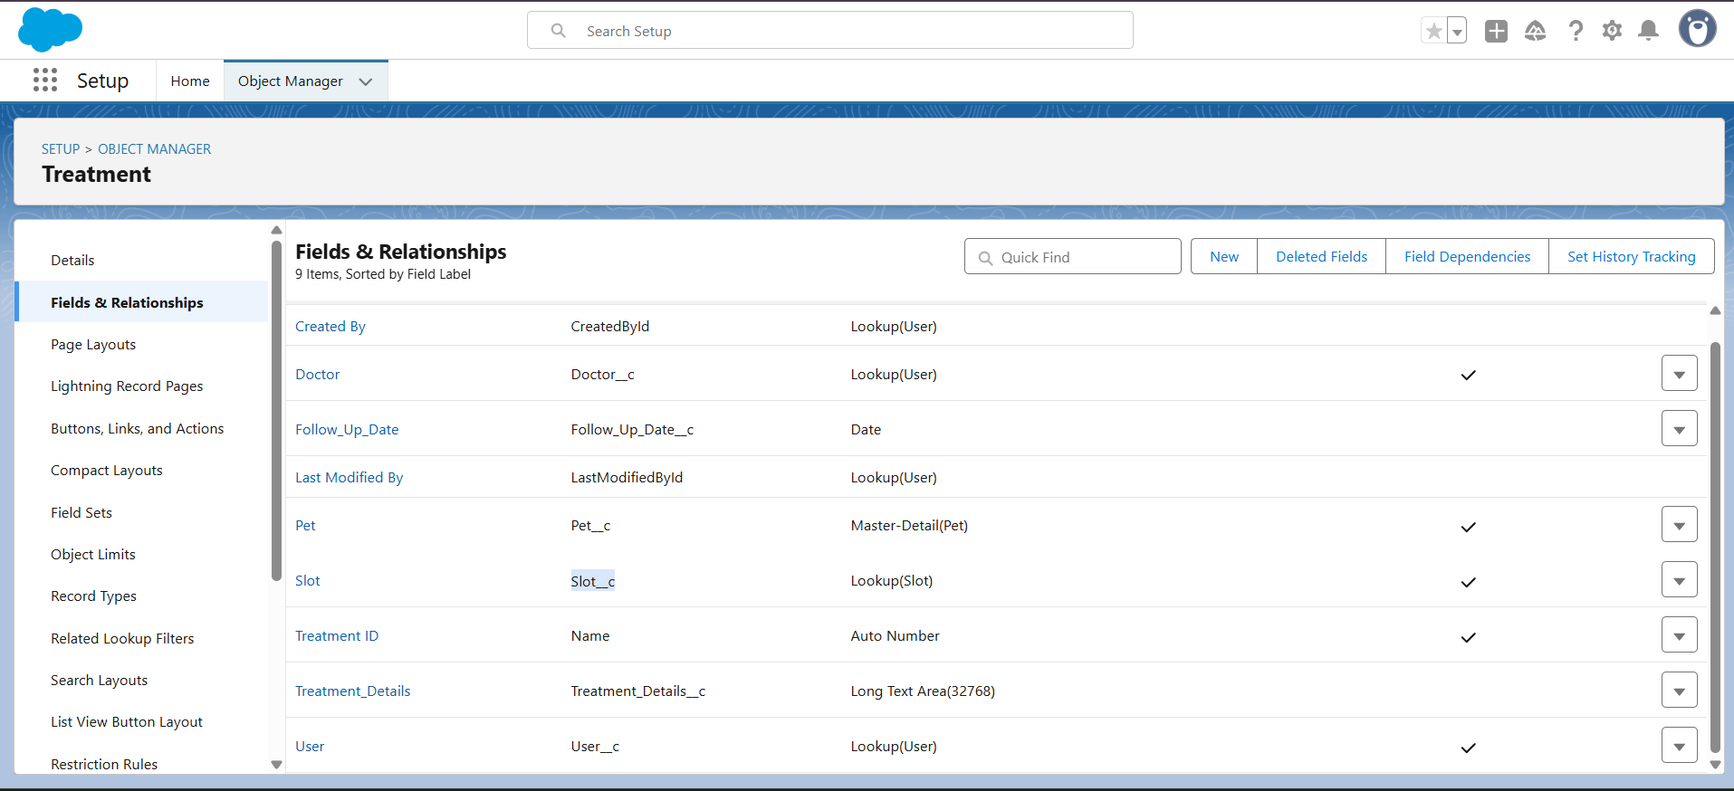

**3.Page Layouts**

* What it does: Controls which fields users can see and edit on each record.
* What you need:
  + Pet Layout: Shows all pet fields.
  + Slot Layout: Shows pet, doctor, appointment date, status, and notes.
  + Treatment Layout: Shows pet, doctor, treatment notes, follow-up, and status.
* How it helps: Ensures different users see only the fields relevant to their role, improving usability and reducing mistakes.

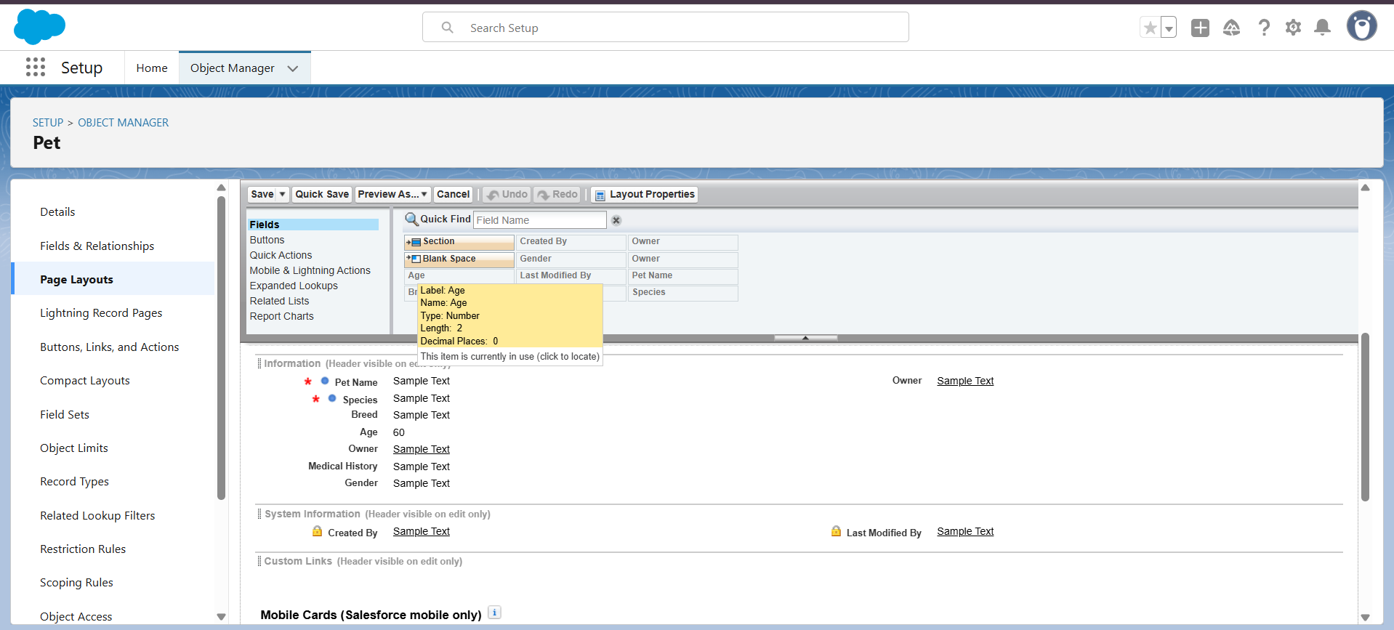

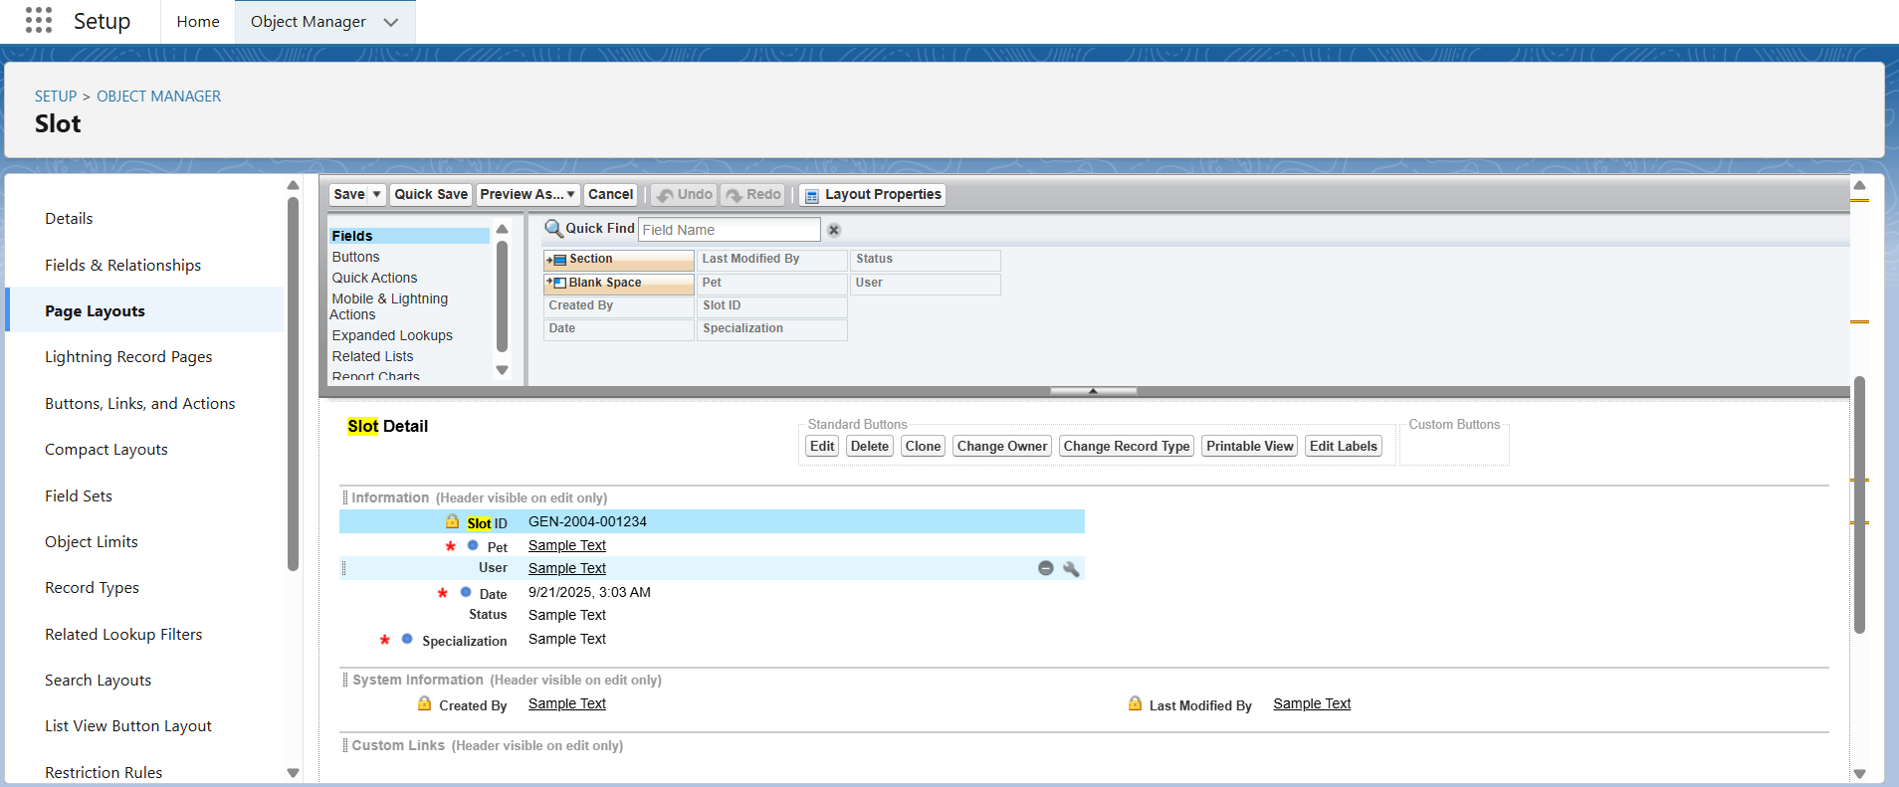

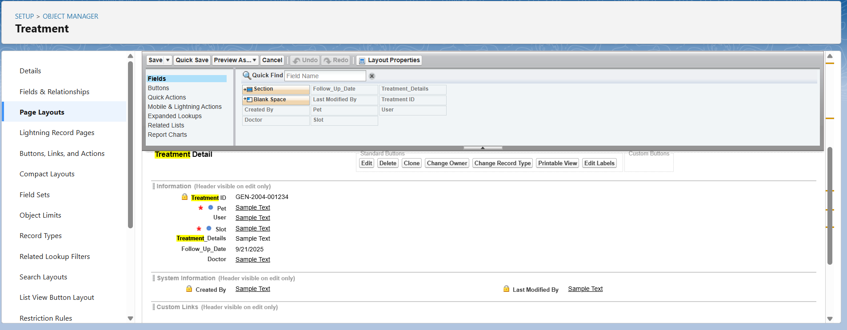

**4. Schema Builder**

* What it does: A visual tool to see objects, fields, and relationships in Salesforce.
* What you need:
  + Use to view Pet__c, Slot__c, Treatment__c, Contact, User.
* How it helps:
  + Provides a clear visual map of all relationships.
  + Useful for planning, documentation, and checking relationships.

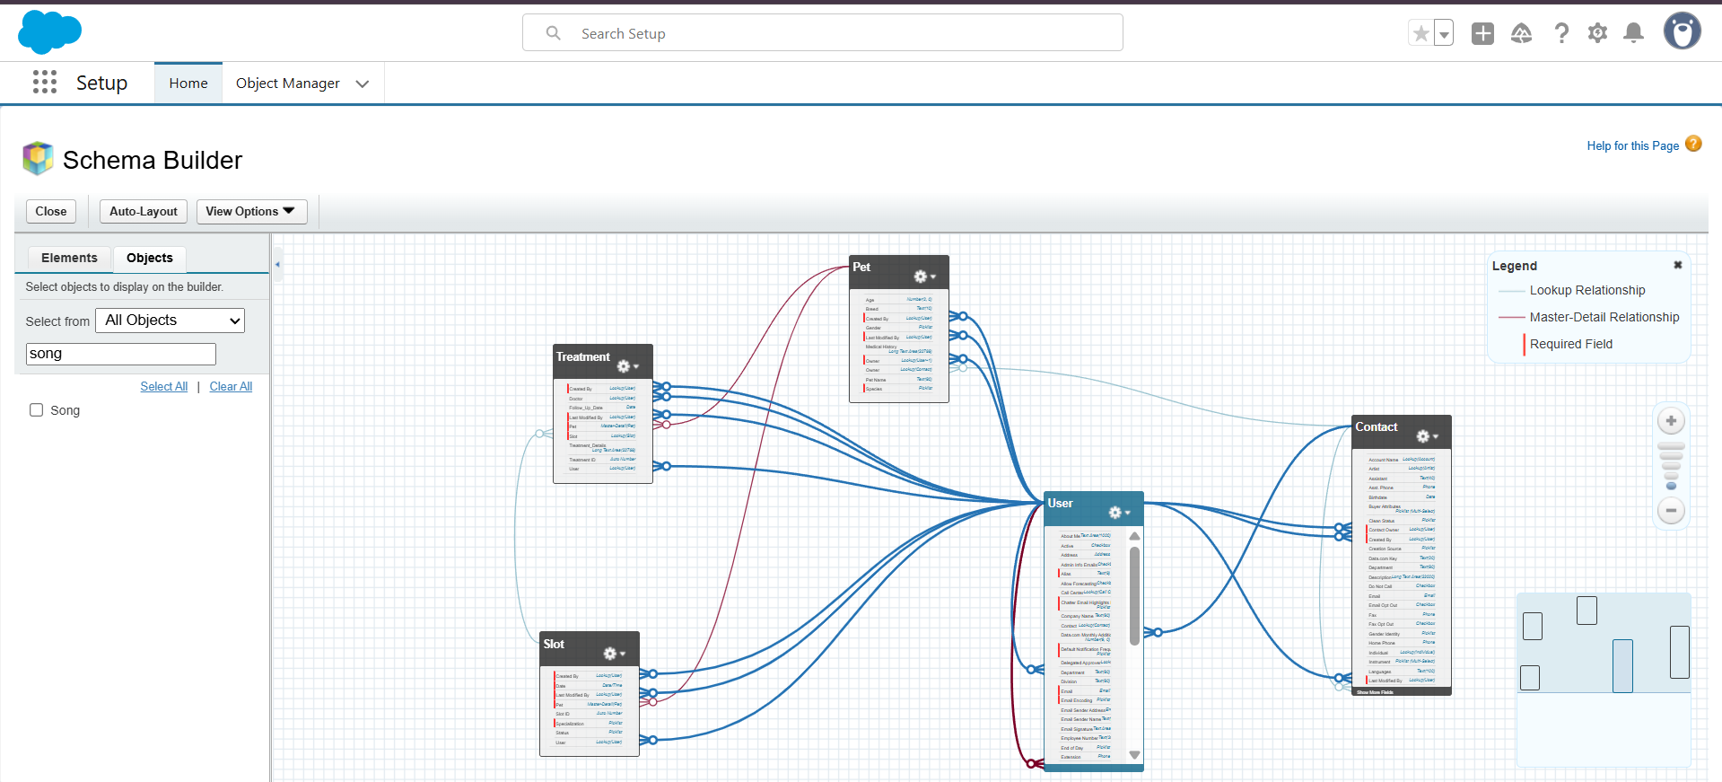

**5. Lookup vs Master-Detail Relationships**

* What it does: Defines how objects are connected.
* What you need:
  + Lookup:
    - Pet → Owner (Contact)
    - Slot/Treatment → Doctor (User)
  + Master-Detail:
    - Slot__c → Pet__c
    - Treatment__c → Pet__c
* How it helps:
  + Lookup allows loose connection; child can exist independently.
  + Master-Detail ensures tight connection; enables roll-up summaries like total slots or treatments per pet.

